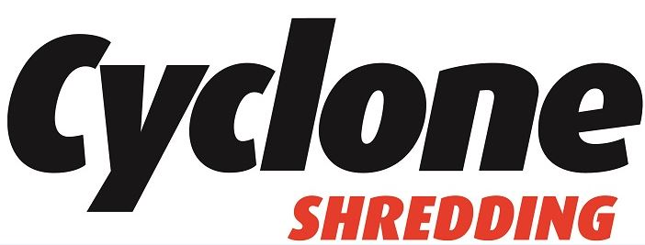

CREDIT ACCOUNT APPLICATION FORM
This form allows us to activate your Cyclone Shredding 30 day credit account and will ensure accurate billing.

COMPANY DETAILS
Company / Business Name:
Billing Address:
Type of Entity (Ltd / Sole Trader / Partnership):
Company Registration No:
VAT Number:
General Contact Email:
Invoicing Email (mandatory):
PO Required? (Yes / No):
Main Phone Number:
Accounts Payable Contact:
AP Phone Number:
AP Email:

TRADE REFERENCES (Optional)
Company: |  | Phone: |  | Contact:
Company: |  | Phone: |  | Contact:

PAYMENT TERMS
Standard credit terms are 30 days from the date of invoice. Where payment terms are not met, Cyclone Shredding reserves the right to suspend services or revert the account to a pay-as-you-go basis.
By signing this form, you confirm that you are authorised to open this credit account and agree to Cyclone Shredding’s standard Terms & Conditions available at www.cycloneshredding.ie/compliance

COMPLIANCE & SECURITY
Cyclone Shredding operates under its Waste Collection Permit and Waste Facility Permit and is an i-SIGMA Member, adhering to the highest certified secure information destruction standards.

DATA PROTECTION
Information provided will be used solely for the activation and management of your Cyclone Shredding credit account and will not be shared with third parties except where required for invoicing or regulatory compliance.

AUTHORISATION
Authorised Signatory:
Job Title:
Mobile Number (optional):
Date:

FOR OFFICE USE ONLY
Account Number:
Start Date & Rate:
Credit Limit Assigned:
Billing Frequency (Weekly / Monthly):
Service Type (Console / Purge / HDD / Other):
Assigned Account Manager:

For a complete list of our services please see our website www.cycloneshredding.ie
